1. Write the structure of:
a. 2-Chloro-3-methylpentane
b. 4-tert-Butyl-3-iodoheptane
2. Why are the boiling point of aldehydes and ketones lower than the
boiling point of corresponding alcohols and carboxylic acids?
3. How is bakelite made and what is its major use? Why is Bakelite a thermosetting plastic?
4. Write the monomer used for getting the following polymers
a. Teflon b. PHBV
5. Arrange the following compounds in increasing order of their acid
strength:
Propan-1-ol, 2, 4, 6-trinitrophenol, 3-nitrophenol, 3, 5-dinitrophenol,
phenol, 4-methylphenol.
6. Write the IUPAC name of:
a. 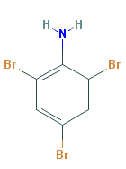 b. 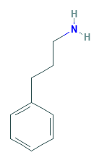
7. Write the important structural and functional differences between DNA and RNA.
8. Explain the mechanism of acid catalysed dehydration of ethanol at high temperature.
9. Account for the following:
a. Aniline dos not undergo Friedel-Crafts reaction.
b. Aromatic primary amines cannot be prepared by Gabriel pthalimide synthesis.
c. Ortho nitrophenol more acidic than ortho methoxyphenol.
10. Give reasons:
a. Propanol has higher boiling point than that of the hydrocarbon butne.
b. Alkyl halide, though polar are immiscible with water.
c. Grignard reagent should be prepared under anhydrous condition.
11.a. Name the reagents used in the following reactions:
i. Oxidation of a primary alcohol to carboxylic acid
ii. Benzyl alcohol to benzoic acid.
iii. Butan-2-one to butan-2-ol.
b. Explain Kolbe’s reaction with an example.
16. What products would you expect from the elimination of the following alkyl halides, which products will be major in each case?

- a. The use of chloroform as anaesthetic is decreasing. Why?
- An alkyl halide (A) on reaction with magnesium in dry ether followed by treatment with ethanol gave 2-methylbutane. Write all the possible structures of (A).
18. Complete each synthesis by giving missing starting material, reagent or
products.
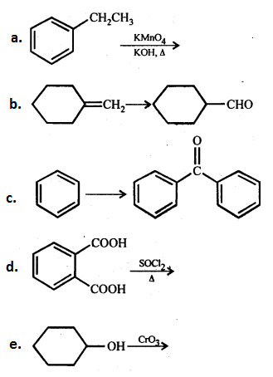
18. Explain the following terms with suitable examples:
a. Cationic detergents
b. Anionic detergents
c. Non-anionic detergents.
19. a. Sucrose is dextrorotatory but the mixture obtained by hydrolysis is
laevorotatory. Explain.
b.Amino acids behave like salts rather than simple amines or carboxylic
acids. Explain.

- Name the vitamin whose deficiency causes the following diseases:
i. Beri-beri ii. Poor coagulation of blood iii. Ricket
b. Predict towards which electrode would an α-amino acid migrate in an
electric field at a:
i. pH=pI ii. pH>pI. Explain.
20. Which of the following compounds would undergo aldol condensation, which the Cannizzaro reaction and which neither? Write the structures of the expected products of aldol condensation and Cannizzaro reaction.
(i)Methanal (ii) 2-Methylpentanal (iii) Benzaldehyde .
(iv) Benzophenone (v) Cyclohexanone (vi) 1-Phenylpropanone
(vii) Phenylacetaldehyde (viii) Butan-l-ol 1 (ix) 2,2-Dimethylbutanal
21. While separating a mixture of ortho and para nitrophenols by steam distillation, name the isomer which will be steam volatile. Give reason.
22. a. Name a broad spectrum antibiotic and two diseases for which it is
prescribed.
b. Why is bithional added to soap?
- Name the class of antimicrobial drugs.
23. How does the presence of a particular ligand affect the thermodynamic
stability of a complex? Illustrate your answer with suitable examples.
24. Write the reaction of HI with the following:
a. 1-Propoxypropane
b. Methoxy benzene
c. Benzyl ethyl ether.
25. A compound A with molecular formula C₄H₈O on oxidation forms a compound B which gives a positive iodoform test. The reaction of B with CH₃Br followed by hydrolysis gives a compound C with molecular formula C₅H₁₂O. Identify A, B, C and D and write the reaction.

25. An organic compound A on heating with sodalime gives B, which reacts with HCN to give C. The compound C reacts with thionyl chloride to produce D which on reaction with KCN gives compound E. Alkaline hydrolysis of E gives a salt F which on heating with sodalime produces n-butane. Careful oxidation of A with dichromate gives acetic acid and malonic acid. Give the structure of A to F.
26. a. Draw other resonance structures related to the following structure and find out whether the functional group present in the molecule is ortho, para directing or meta directing.
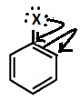
b. Which of the following compounds would undergo S_{N}1 reaction faster and why?
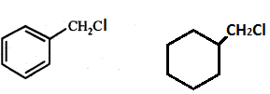

- Arrange the following in order of their expected S_{N}1 reactivity.
CH₃CH(Br)CH₃, CH₃CH₂Br, CH₂=CHBr, CH₂=CHCH(Br)CH₃
- An optically active compound having molecular formula C₇H₁₅Br reacts with KOH to give a racemic mixture of products. Write the mechanism involved for the reaction.
- How will you convert the following:
- Propane to allyl chloride
- Methyl bromide to acetic acid.
27. a. Glucose does not give 2, 4-DNP test and Schiff’s test. Why?
b. Write the two reactions of glucose which could not be explained by open
chain structure of glucose molecule.
c. What are the products of hydrolysis of Sucrose and Lactose.
d. Give one example each of disaccharide and polysaccharide.
e. Is a diet consisting mainly of rice an adequate diet? Justify your answer.

- How do anomer different from epimer?
- What are the polysaccharides that make up starch and what is the difference between them.
- Name the disaccharide present in milk.

28. Value of standard electrode potential for the oxidation of Cl⁻ ions is more positive than that of water, even then in the electrolysis of aqueous sodium chloride, why is C l⁻ oxidised at anode instead of water?
22. Explain why the stability of oxoacids of chlorine increases in the order given below.
HClO < HClO2< HClO3 < HClO₄
29. Complete each synthesis by giving missing starting material, reagent or
products.
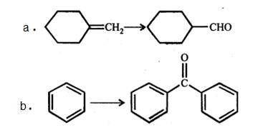
30. Explain the following phenomena with the help of Henry's law.
(i) Painful condition known as bends.
(ii) Feeling of weakness and discomfort in breathing at high altitude.
(b) Why soda water bottle kept at room temperature fizzes on opening

31. Draw one of the geometrical isomers of the complex [Pt(en)₂Cl₂]²⁺ which is optically inactive. Also write the name of this entity according to the IUPAC nomenclature.

Indicate the type of isomerism in the following set of complex compounds.
a) [Co(NH₃)₅Cl]SO₄ and [Co(NH₃)₅ SO₄]Cl
b) [Co(NH₃)₅(SCN)]Cl₂ and [Co(NH₃)₅(NCS)]Cl₂
32. What are the conditions that Mg can reduce Al2O3 and Al can reduce MgO?
Write and explain the reactions involved in the extraction of gold.
33. a. Draw other resonance structures related to the following structure and find out whether the functional group present in the molecule is ortho, para directing or meta directing.
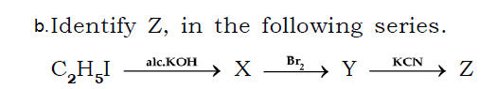
34. On adding solute having vapour pressure 0.80 atm, vapour pressure reduces to 0.60 atm. Calculate the mole fraction of the solute.
29. State Kohlrausch law. Calculate Limiting molar conductivity of NaCl, HCl and NaAc are 126.4, 425.9 and 91 S Cm² mol⁻¹. Calculate Limiting molar conductivity of HAc.

35. The EMF of following reaction is 0.28V at 25º C
Zn + 2H⁺ → Zn²⁺ + H₂ (1 atm) E°cell = 0.76 V. Calculate pH of solution at hydrogen electrode.
30. Answer the following questions:
(a) Which of the following electrolytes is most effective for the coagulation of AgI/Ag⁺ sol?
a. MgCl₂, K₂SO₄, K₄[Fe(CN)₆]
(b) What happens when a freshly precipitated Fe(OH)₃ is shaken with a little amount of dilute solution of FeCl₃.
(c) Out of sulphur sol and proteins, which one forms macromolecular colloids?

31. Account for the following:
a) Moist SO₂ decolourises KMnO4 solution.
b) Why does fluorine and oxygen exhibit an anomalous behavior as compared to the other halogens in the group?
c) Ozone acts as a powerful oxidizing agent.
32. Identify the product formed when propan-1-ol is treated with Conc. H₂SO₄ at 413 K . Write the mechanism involved for the above reaction.

33. a. Why are the boiling point of aldehydes and ketones lower than the
boiling point of corresponding alcohols and carboxylic acids?
b. Give chemical tests to distinguish between the following pairs of compounds:
Ethanal and Propanone

- While separating a mixture of ortho and para nitrophenols by steam distillation, name the isomer which will be steam volatile. Give reason.
- Explain Kolbe’s reaction with an example
34. 18. Explain the following terms with suitable examples:
a. Cationic detergents
b. Anionic detergents
c. Non-anionic detergents.
35. a. The half-life for radioactive decay of 14C is 5730 years. An archaeological
Artifact containing wood had only 80% of the 14C found in a living tree.
Estimate the age of the sample.
- Arrange the following metals in order of their increasing reducing power.
K⁺/K = - 2.93V, Ag+/Ag = 0.80V, Hg2+/Hg = 0.79 V, Mg2+/Mg = - 2.37 V
Cr^{3+/}Cr = - 0.74V.
- The conductivity of 0.20m solution of KCl at 298 K is 0.0248 Scm-1. Calculate its molar conductivity.
OR

- Calculate the degree of dissociation of 0.0024 M acetic acid if conductivity of this solution is 8.0 × 10-5 S cm-1.
- Solutions of two electrolytes ‘A’ and ‘B’ are diluted. The limiting molar conductivity of ‘B’ increases to a smaller extent while that of ‘A’ increases to a much larger extent comparatively. Which of the two is a strong electrolyte? Justify your answer.
36. Predict the reagent or the product in the following reaction sequence.
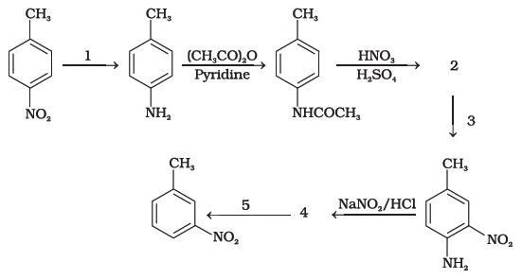
- Which is the strongest base among the following? Explain.

- Why does the acetylation of –NH2 group of aniline reduce its activating effect?
- What is the role of pyridine in acylation of amines?
37. a. Name the metal of the 1st row transition series that:
i) has highest value for magnetic moment ii) has zero spin only magnetic moment in its +2 oxidation state. iii) Exhibit maximum number of oxidation states.
b. What is ‘disproportionation’ of an oxidation state? Give one example of disproportionation reaction in aqueous solution.
c. The chemistry of actionoids is more complicated than lanthanoids. Why?

- Describe the preparation of potassium permanganate from manganese dioxide.
- How does the acidified permanganate solution react with (a) iron(II) ions (b) oxalic acid and (c) hydrogen sulphide ? Write the ionic equations for the reactions In acid solutions:

